1. **Sdlc and stlc**

**SDLC**

Software Development Life Cycle (SDLC) defines all the standard phases which are involved during the software development process. [SDLC life cycle](https://www.guru99.com/software-development-life-cycle-tutorial.html) is a process of developing software through a phased manner in the following order

Requirements Gathering

Design the software

Build the Software

Test

Deployment

Maintenance.

Each stage has definite entry and exit criteria along with deliverables.

**STLC**

Software Testing Life Cycle (STLC) is the testing process that is executed in a well-planned manner. In the STLC process, various activities are carried out to improve the quality of the product. However, [STLC phases](https://www.guru99.com/software-testing-life-cycle.html) only deal with testing and detecting errors but not development itself.

Different companies define different phases in STLC. However, generic Software Test Life Cycle has the following stages.

Requirement Analysis

Test Planning

Test Development

Test Environment Setup

Test Execution & Closure

## 

1. **what is agile testing**

What Is Agile Testing?

Agile testing is a software testing practice that follows the Agile software development methodology. In [Agile development](https://www.microfocus.com/what-is/agile-development), projects tend to evolve during each sprint among collaborators and shareholders. Agile testing focuses on ensuring quality throughout the Agile software development process.

Continuous integration and continuous delivery are two important aspects of agile testing. In continuous integration, developers integrate their code changes into a shared mainline several times a day. In continuous delivery, every change that passes all tests is automatically released into production.

* Test scenario and test case
* **bug investigation and reporting**

1. **What is Bug life cycle**

**New:** When a new defect is logged and posted for the first time. It is assigned a status as NEW.

**Assigned:** Once the bug is posted by the tester, the lead of the tester approves the bug and assigns the bug to the developer team

**Open**: The developer starts analyzing and works on the defect fix

**Fixed**: When a developer makes a necessary code change and verifies the change, he or she can make bug status as “Fixed.”

**Pending retest**: Once the defect is fixed the developer gives a particular code for retesting the code to the tester. Since the [software testing](https://www.guru99.com/software-testing-introduction-importance.html) remains pending from the testers end, the status assigned is “pending retest.”

**Retest**: Tester does the retesting of the code at this stage to check whether the defect is fixed by the developer or not and changes the status to “Re-test.”

**Verified**: The tester re-tests the bug after it got fixed by the developer. If there is no bug detected in the software, then the bug is fixed and the status assigned is “verified.”

**Reopen**: If the bug persists even after the developer has fixed the bug, the tester changes the status to “reopened”. Once again the bug goes through the life cycle.

**Closed**: If the bug is no longer exists then tester assigns the status “Closed.”

**Duplicate**: If the defect is repeated twice or the defect corresponds to the same concept of the bug, the status is changed to “duplicate.”

**Rejected**: If the developer feels the defect is not a genuine defect then it changes the defect to “rejected.”

**Deferred**: If the present bug is not of a prime priority and if it is expected to get fixed in the next release, then status “Deferred” is assigned to such bugs

**Not a bug**: If it does not affect the functionality of the application then the status assigned to a bug is “Not a bug”.

1. test artifacts and agile testing  
     
   Test Artifacts are simply integral part of software testing. These are generally set of documents, which software project tester gets during STLC (Software Testing Life Cycle). Test artifacts are by-products that are generated or created while performing software testing. These generated test artifacts are then shared with clients and testing team or team managers, team leaders, stakeholders associated with project, and also with members of other team.  
   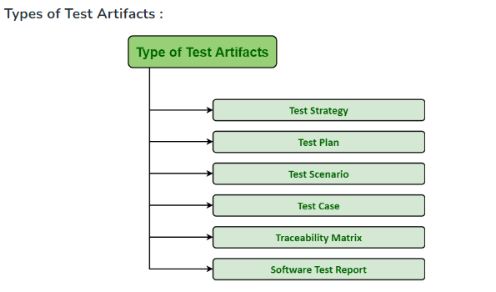
2. release management
3. test plan and test strategy
4. test estimations
5. types of testing